Thread Management using POSIX Library - Detachment and Cancellation assignments

Mandatory

- Write a program to create 3 threads with the detach and cancel status as below.

Thread# | Detached (Y/N) | Cancel type | Cancel status
1 | Y | PTHREAD_CANCEL_DISABLE
2 | N | PTHREAD_CANCEL_ENABLE | PTHREAD_CANCEL_DEFERRED
3 | N | PTHREAD_CANCEL_ENABLE | PTHREAD_CANCEL_ASYNCHRONOUS

- Let all the threads read and display their detach, cancel type and status and then display thread specific message as below.
T1: Display message in the format as below every 2 secs
<timestamp> Health OK
T2: Print numbers starting from 1000 in steps of 2 at an interval of 3 secs in format as below.
<timestamp> <threadid> <countvalue>

T3: Print numbers starting from 2000 in steps of 2 at an interval of 3 secs
<timestamp> <threadid> < countvalue >
- Code:
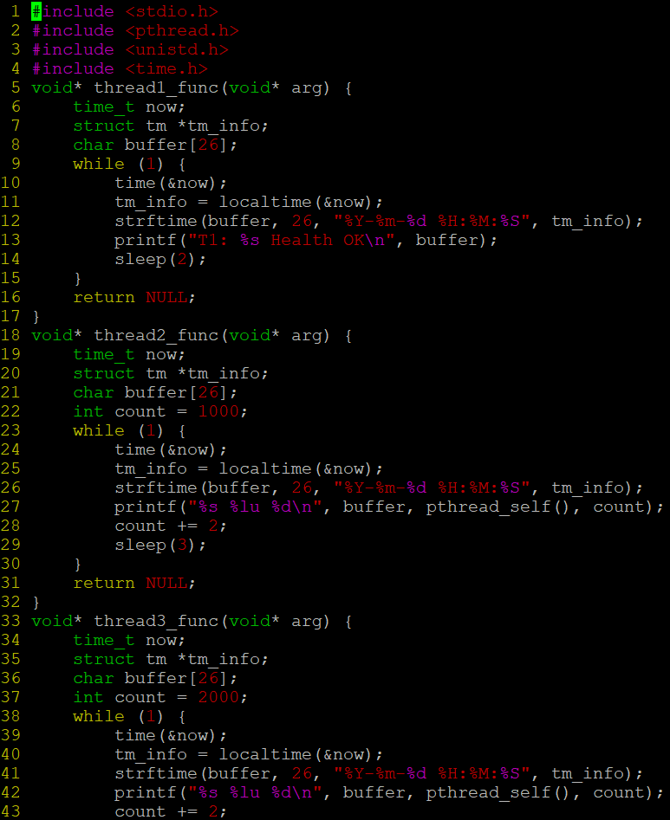

- After creating threads, and after 3 minutes from main(), cancel all 3 threads
- 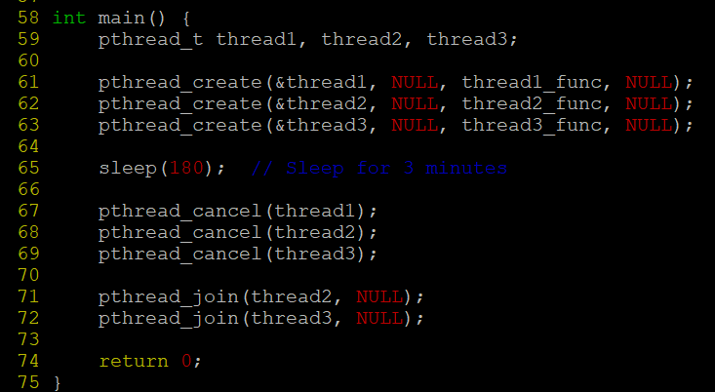
- From an other terminal, use command below to view the thread count of your program
    - ps -eLF
    - top
[For top command usage to refer https://www.golinuxcloud.com/check-threads-per-process-count-processes/ ]
- What difference did you observe between top and ps command?
- top is used to see which processes are most active and ps is used to see which processes are running currently.
- Which column shows the number of threads in ps and in top commands?
- In ps -eLF, NLWP column shows the number of threads and
In top, THR column shows the number of threads for each process
- Check the last message timestamp from the threads
- 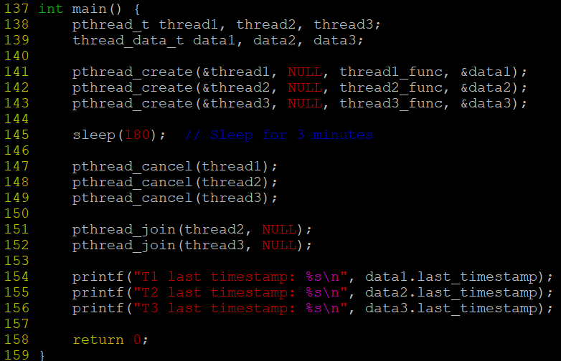
- Which thread was cancelled first and why?
- Thread 3 was canceled first because it uses asynchronous cancellation, which immediately responds to the cancellation request.
- Were all 3 threads cancelled? Justify the observation
- No, all three threads were not canceled because Thread 1 had cancellation disabled, so it was not affected by the cancel request.

